ASSIGNMENT

**Submitted by:**

**Roll No:** 2017-CS-

**Section: ‘**C’

**Course Name:**  DATA STRUCTURE

**Submitted To:** SIR FARAZ

Q.1 Code a function in C++ to traverse the elements of an array.

#include <iostream>

using namespace std;

int main()

{

int test[10] = { 1, 2, 3, 4, 5, 6, 7, 8, 9, 10 };

for (int i = 0; i < 10; ++i) {

cout << test[i] << endl;}

return 0;

}

**OUTPUT**

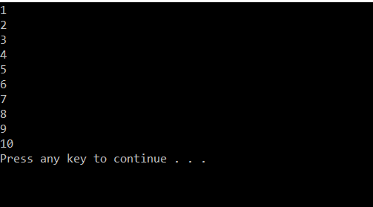

Q.2 Write a C++ program to find the sum and average of one dimensional integer array.

#include <iostream>

using namespace std;

int main()

{

int total = 0;

int avg;

int n = 7;

int y[7] = { 6,9,2,4,5,23,12 };

for (int i = 0; i<n; i++)

{

cout << y[i] << " "<<endl;

total = total + y[i];

avg = total / 7 ;

}

cout << "Sum" << total << endl;

cout << "Average" << avg << endl;

system("pause");

return 0;

}

**OUTPUT**

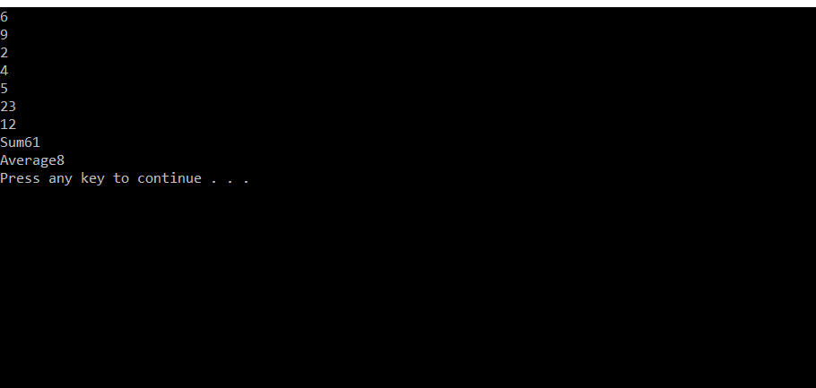

Q.3 Write a C++ program to swap first and last element of an integer 1-d array.

#include<iostream>

using namespace std;

int main()

{

int Arr[5] = { 0,1,2,3,4 };

int i, temp;

temp = Arr[0];

Arr[0] = Arr[5 - 1];

Arr[5 - 1] = temp;

cout << "\nArray after swapping" << endl;

for (i = 0; i<5; i++) {

cout << Arr[i] << " ";

}

system("pause");

return 0;

}

**OUTPUT**

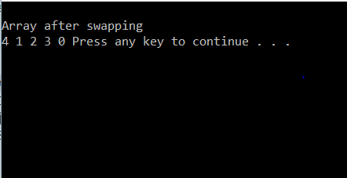

Q. 4 Write a C++ program to reverse the element of an integer 1-D array.

#include<iostream>

#include<conio.h>

using namespace std;

void main()

{

int arr[5] = { 0,1,2,3,4 };

int i, j, temp;

for (i = 0; i<5; i++)

{

cout << arr[i]<< " ";

}

j = i - 1;

i = 0;

while (i<j)

{

temp = arr[i];

arr[i] = arr[j];

arr[j] = temp;

i++;

j--;

}

cout << "\n Now the Reverse of the Array is : \n";

for (i = 0; i<5; i++)

{

cout << arr[i] << " ";

}

cout << endl;

system("pause");

}

**OUTPUT**

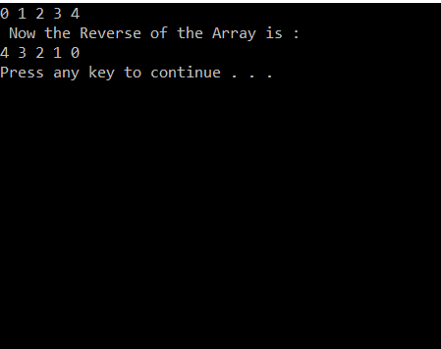

Q. 5 Write a C++ program to find the largest and smallest element of an array.

#include<iostream>

using namespace std;

int main()

{

int highNum = 0;

int m;

int list[4] = { 10, 4, 7, 8 };

int LowNum = list[0];

for (m = 0; m < 4; m++)

{

if (list[m] > highNum) {

highNum = list[m];

}

if (list[m] < LowNum) {

LowNum = list[m];

}

///cout << list[m];

}

cout << highNum<<endl;

cout << LowNum;

system("pause");

return 0;

}

**OUTPUT**

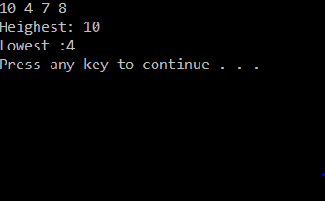

Q.6 Write a Menu driven Program which have the following options :

Select the menu from the List : 1. Addition Of Matrix 2. Subtraction of Matrix 3. Multiplication Of Matrix 4. Exit.

#include <iostream>

using namespace std;

int main()

{

char op;

int r, c, a[100][100], b[100][100], sum[100][100], i, j;

cout << "Enter Choice \n 1.Addition of Matrix \n 2.Subtraction of Matrix \n 3.Multiplication of Matrix \n 4.Division of Matrix \n 5.Exit " << endl;

cin >> op;

cout << "Enter number of rows (between 1 and 100): ";

cin >> r;

cout << "Enter number of columns (between 1 and 100): ";

cin >> c;

cout << endl << "Enter elements of 1st matrix: " << endl;

for (i = 0; i < r; ++i)

for (j = 0; j < c; ++j)

{

cout << "Enter element a" << i + 1 << j + 1 << " : ";

cin >> a[i][j];

}

cout << endl << "Enter elements of 2nd matrix: " << endl;

for (i = 0; i < r; ++i)

for (j = 0; j < c; ++j)

{

cout << "Enter element b" << i + 1 << j + 1 << " : ";

cin >> b[i][j];

}

switch (op)

{

case '1':

for (i = 0; i < r; ++i)

for (j = 0; j < c; ++j)

sum[i][j] = a[i][j] + b[i][j];

cout << endl << "Sum of two matrix is: " << endl;

for (i = 0; i < r; ++i)

for (j = 0; j < c; ++j)

{

cout << sum[i][j] << " ";

if (j == c - 1)

cout << endl;

}

break;

case '2':

for (i = 0; i < r; ++i)

for (j = 0; j < c; ++j)

sum[i][j] = a[i][j] - b[i][j];

cout << endl << "Subtraction of two matrix is: " << endl;

for (i = 0; i < r; ++i)

for (j = 0; j < c; ++j)

{

cout << sum[i][j] << " ";

if (j == c - 1)

cout << endl;

}

break;

case '3':

for (i = 0; i < r; ++i)

for (j = 0; j < c; ++j)

sum[i][j] = a[i][j] * b[i][j];

cout << endl << "Multiplication of two matrix is: " << endl;

for (i = 0; i < r; ++i)

for (j = 0; j < c; ++j)

{

cout << sum[i][j] << " ";

if (j == c - 1)

cout << endl;

}

break;

case '4':

for (i = 0; i < r; ++i)

for (j = 0; j < c; ++j)

sum[i][j] = a[i][j] / b[i][j];

cout << endl << "Division of two matrix is: " << endl;

for (i = 0; i < r; ++i)

for (j = 0; j < c; ++j)

{

cout << sum[i][j] << " ";

if (j == c - 1)

cout << endl;

}

break;

case '5':

break;

default:

cout << "Error! Incorrect Choice";

break;

}

system("pause");

return 0;

}

**OUTPUT**

